Texas Cattlewomen Executive Board Notes
3:00 PM on March 25th, Ft. Worth Convention Center
Full Officer Attendance: Linda Thorman, Sharon Meiers, Debbie Gill, Casey Matzke, Marsha Shoemaker, Diane Travis

We discussed having a Liaison relationship from TCW with the local chapters to improve communication, share ideas and participation. We discussed having Exec Board Members going to local meetings. We decided to discuss this in the meeting the next day to get feedback from Board of Directors. One idea is for the first year or so to have Exec Board Members fill this role and then have a local chapter member fill this role to increase participation opportunities.
We reviewed the revised Long-Range Plan for TCW. We will present to the Board of Directors tomorrow.
We discussed the nomination of a person for the Cattleman’s Beef Board. We need to make a call for nominations and select tow names to submit. Debbie Gill is interested in running again. These names are due to Secretary of Agriculture by June 1.
Marsha Shoemake gave a Treasurer’s report. The primary change is that the stock is down 4K due to the recent market down turn but have not lost all the gains from last year.

Board of Directors Meeting
4:00 PM on March 25th , Ft. Worth Convention Center
Attendance: TCW Officers - Linda Thorman, Sharon Meiers, Debbie Gill, Casey Matzke, Marsha Shoemaker, Diane Travis
Local Presidents & Committee Chairs
Portia Olson – East Texas
Lindsey Alexander – Colorado
Doris Cane - Washington
Martha Crump – Wichita Falls

During the Board of Directors Meeting, we reviewed the new TCW Long Range Plan presented by Marsha Shoemaker. Marsha Shoemaker presented the TCW Financial Report. The budget for 2022 was presented. A motion was made by Martha Crump to accept the financials as presented and Portia Olson seconded. We discussed the opportunities for Grilling 101 and the upcoming events for Women in Ranching. We discussed having a Liaison for the Chapters with the Executive Board. It was determined the Executive Board members would serve as the liaison until we get the program running smoothly with the chapters.
Texas Cattlewomen General Membership Annual Meeting
9:00- 5:00 on March 25th, Ft. Worth Convention Center
Fall TCW Meeting Dates: September 30 – October 2, 2022

Executive Officer Attendance: Linda Thorman, Sharon Meiers – Vice President, Debbie Gill - Past President, Casey Matzke- President, Marsha Shoemaker - Treasurer, Diane Travis – Secretary
Member Attendance:
Emilee Haubner – Colorado River
Desta Crawford – Hereford
Maeley Herring – Wichita Falls
Ann Parkey – Wichita Falls
Jennifer Herring – Wichita Falls
Lindsey Alexander – Colorado River
Ruth Coffee – Oklahoma Cattlewomen, ANCW Board
Amy Brainard – Top O’ Texas
Lilith Brainard – Top O’ Texas
Ely Brainard – Top O’ Texas
Doris Kahney – Washington
Thuy & Jackie Grimes - Texas Coastal
Rosia Newsom - Washington
Debbie Wellman – Washington
Dot Borchgarde – Washington
Pam Bothe – Washington
Caitlyn Buchanon – Grasslands
Liz Anthony – Hereford
Kylie Siddoway – Aggie
Jamie Griffin – Aggie
Allyson Reyna – Aggie
Kali Jo Bentz – Aggie
Martha Crump – Wichita Falls
Courtney Herrera – Sam Houston
Sarah Simon – Sam Houston
Aerial Bass – San Houston
Hannah Neal – Sam Houston
Tina Loeffler – Colorado
Deidra Nixon – Colorado
Portia Olson – East Texas
Carrie Shirley – Northeast Texas
Martha Vogelsang – Brazos Valley
Berklee Clements – Top O’ Texas
Sally Wicker – Top 0’ Texas

Agenda: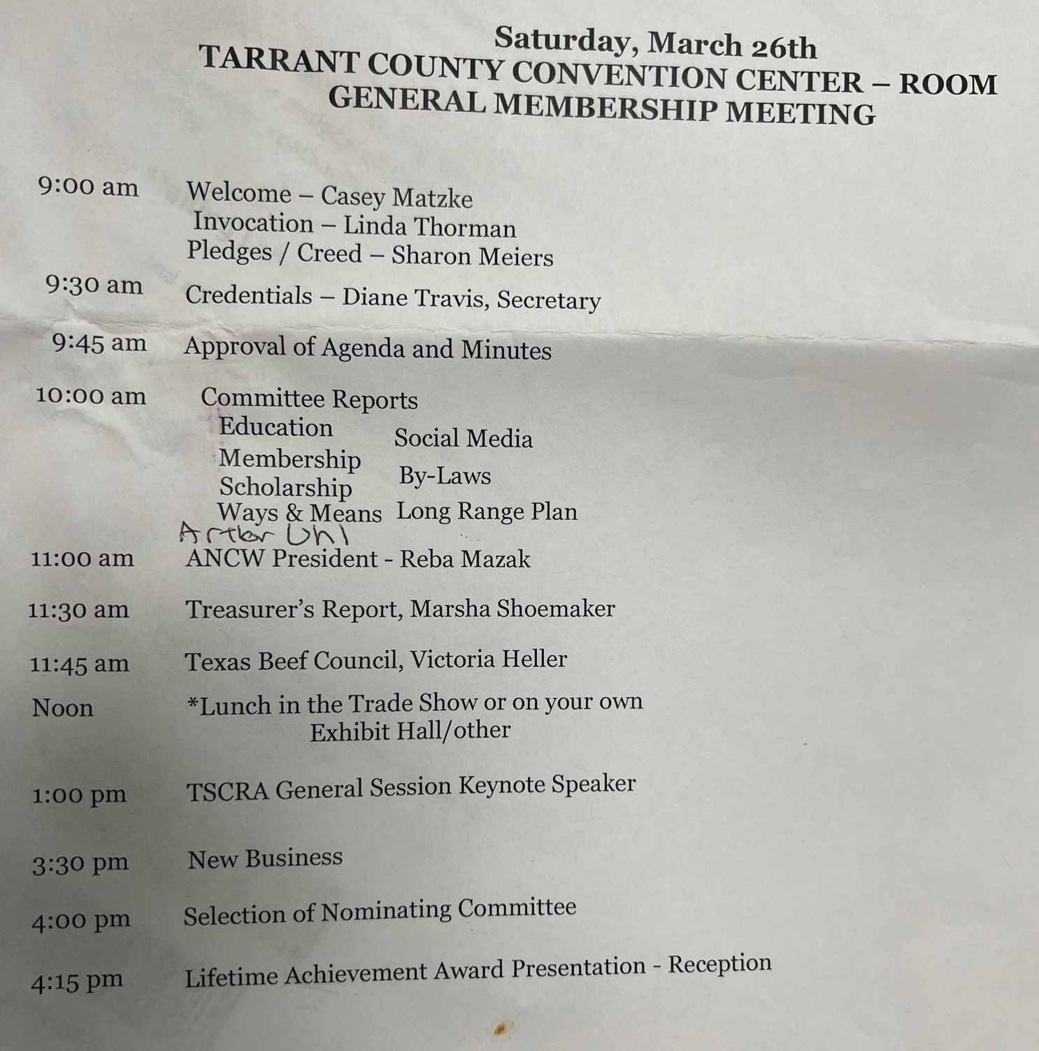
Arthor Uhl – President of TSCRA spoke to TCW.

Meeting Minutes from the Fall Meeting were presented. Amy Brainard made a motion to accept the Fall meeting minutes as presented and Desta Crawford seconded the motion. The Meeting minutes were approved. Linda made the motion to accept the general meeting agenda and Amy Brainard seconded. The Meeting Agenda was approved.
We recognized past presidents in attendance: Tina Lepper, Pam Bothe, and Doris Cane (sp?)
Membership Committee – Please send in chapter membership for the upload into wild apricot or new website system. We have the excel form to submit on the website. Members should login with email and click forgot password the first time they want to login to new website. If that does not work, Please contact executive board member and we can update you email address. Once a member has logged in they can change all your personal profile information. Members can register to join online the website. However, we encourage them to pay their local chapter if they have one to make sure they are properly created in the local chapter. If the website says you have not paid, please check with local chapter first and make sure they have submitted membership to TCW. This is still in process of being updated. We are adding button so that all At-Large members can easily pay online.
Scholarship Committee – A request for volunteers for this years committee. Erin Wolrali will lead committee. Tina Loeffler, Lindsey Alexander, Martha Crump were chosen to serve. Desta Crawford is an alternate if needed.
Ways & Means – A new T-shirt is in the booth and available for sale. It has a shoulder patch that recognizes the 50th Anniversary. We asked for suggestions moving forward. We talked about doing an apron with brands of TCW members. We also plan to do a cookbook in 2022.
Social Media Committee – Please let us know if you would like to serve on this committee.
By-Laws Committee – We did an initial review of by-laws and looked at ANCW by-laws. No changes were suggested. We are looking for committee members.
Long Range Planning Committee – Reviewed our old long range plan, ANCW new plan, Texas Beef Council Plan and developed a new 5 year plan. This new plan is available on website. We condensed to objectives and mission and eliminated any how to suggestions. Those should be part of chapter books. Debbie Gill presented the long range plan and Doris seconded it. The Long rangle plan was accepted.
TBLT Program Update – Texas Beef Leader will be renamed Texas Beef Ambassador to match other states. We are looking for high school seniors. August 1 is the application deadline. Sept 9th for selection and Sept 12th will be the first meeting. BQA certification and Beef Leadership are part of program. Team of 5 first year to speak at events and talk to consumers.
Arthor Uhl, TSCRA President, came to talk about TSCRA plans. We encourage every TCW member to be a member of TSCRA. The TSCRA summer meetings are in Santa Fe, June 8-9.
Fall TCW Meeting Dates: September 30 – October 2, 2022
If your chapter uses the TCW names and logo the local chapter need to get it approved by the TCW executive committee.
Fall Tour – Any suggestions for fall tour send them in now. We are leaning towards Hill country and central Texas.
70 Years of ANCW!
2022 American National Cattle Women President Reba Mazak, from Florida came to present to TCW. Highly encourage you to watch her youtube made March 5, 2022 about our new President. https://www.youtube.com/watch?v=Qebbbqu4SMU ANCW is celebrating 70 years this year. TCW is 50 years old. Reba encouraged us to find our passion and participate in TCW and ANCW. There is place for you in both organizations and a way for you to participate.
Treasurer report was given by Marsha Shoemaker as of March 24th.
Victoria Heller with the Texas Beef Council talked about producer education and communication. She also talked about tools for consumer and youth education developed with our Beef Checkoff dollars. BeeflovingTexans.com/Resources is the place to check. They have a new website coming in May. They have a goal of putting the USDA Plate poster into every school, this is a great activity for chapters and they can provide the posters for you. We ask that each chapter select one person to work with Texas Beef Council and that their chapter President be include on emails to make sure all the correct forms are submitted for funding. Victoria@txbeef.org. Please give them 3 or more weeks minimum for events. Be sure to order the latest materials and do not use material with older messaging. If you order materials , you must submit activity report. Everyone is invited to the June TX Beef Council Meeting. It is impressive where our dollars are going to improve the industry. Please sign up for the Cattle Talk newsletter that is online. Go to Texas Beef Council website to signup.
The nominating committee was selected. Martha Vogelsang, Debbie Wellman, Liz Anthony, Callie ?
The 2022 TCW Lifetime Achievement Award was presented to Ann Parkey with Wichita Falls Cattlewomen.

